SYSTEM DESIGN DOCUMENT
Task 2: Data Pipeline Design

1. Executive Summary
This document proposes a shipment data pipeline. The system ingests shipment records containing client, route, cargo, weight, value and status information, validates and normalizes the data, stores it in a reliable operational database and processes it into three business outputs:
- Daily summary dashboard: operational visibility into shipment volumes, status, cargo, weight, value, and revenue.
- Overdue shipment alerts: automatic detection and notification of shipments that require operational attention.
- 30-day revenue forecast: a daily forecast of expected revenue for the next 30 days using historical revenue and known future shipments.
The design intentionally uses a relatively simple architecture which is Django, Celery, Redis, PostgreSQL, Python forecasting tools and Streamlit, rather than introducing heavyweight data-engineering infrastructure that is not necessary for the expected scale.

2. Business Requirements

2.1 Input Data
The pipeline must ingest shipment data containing at least:
Field | Description
shipment_id | Unique identifier for the shipment
client_name | Customer/client associated with the shipment
origin | Shipment origin
destination | Shipment destination
cargo_type | Type/category of cargo
weight_kg | Shipment weight
value_usd | Declared shipment/cargo value
status | Current shipment status

Additional operational fields such as ETA, vessel berth date, timestamps, and invoiced revenue are recommended because they support overdue detection, operational reporting, and revenue forecasting.

2.2 Required Outputs
The pipeline must produce:
- A daily summary dashboard.
- Overdue shipment alerts.
- A 30-day revenue forecast.

3. High-Level System Architecture
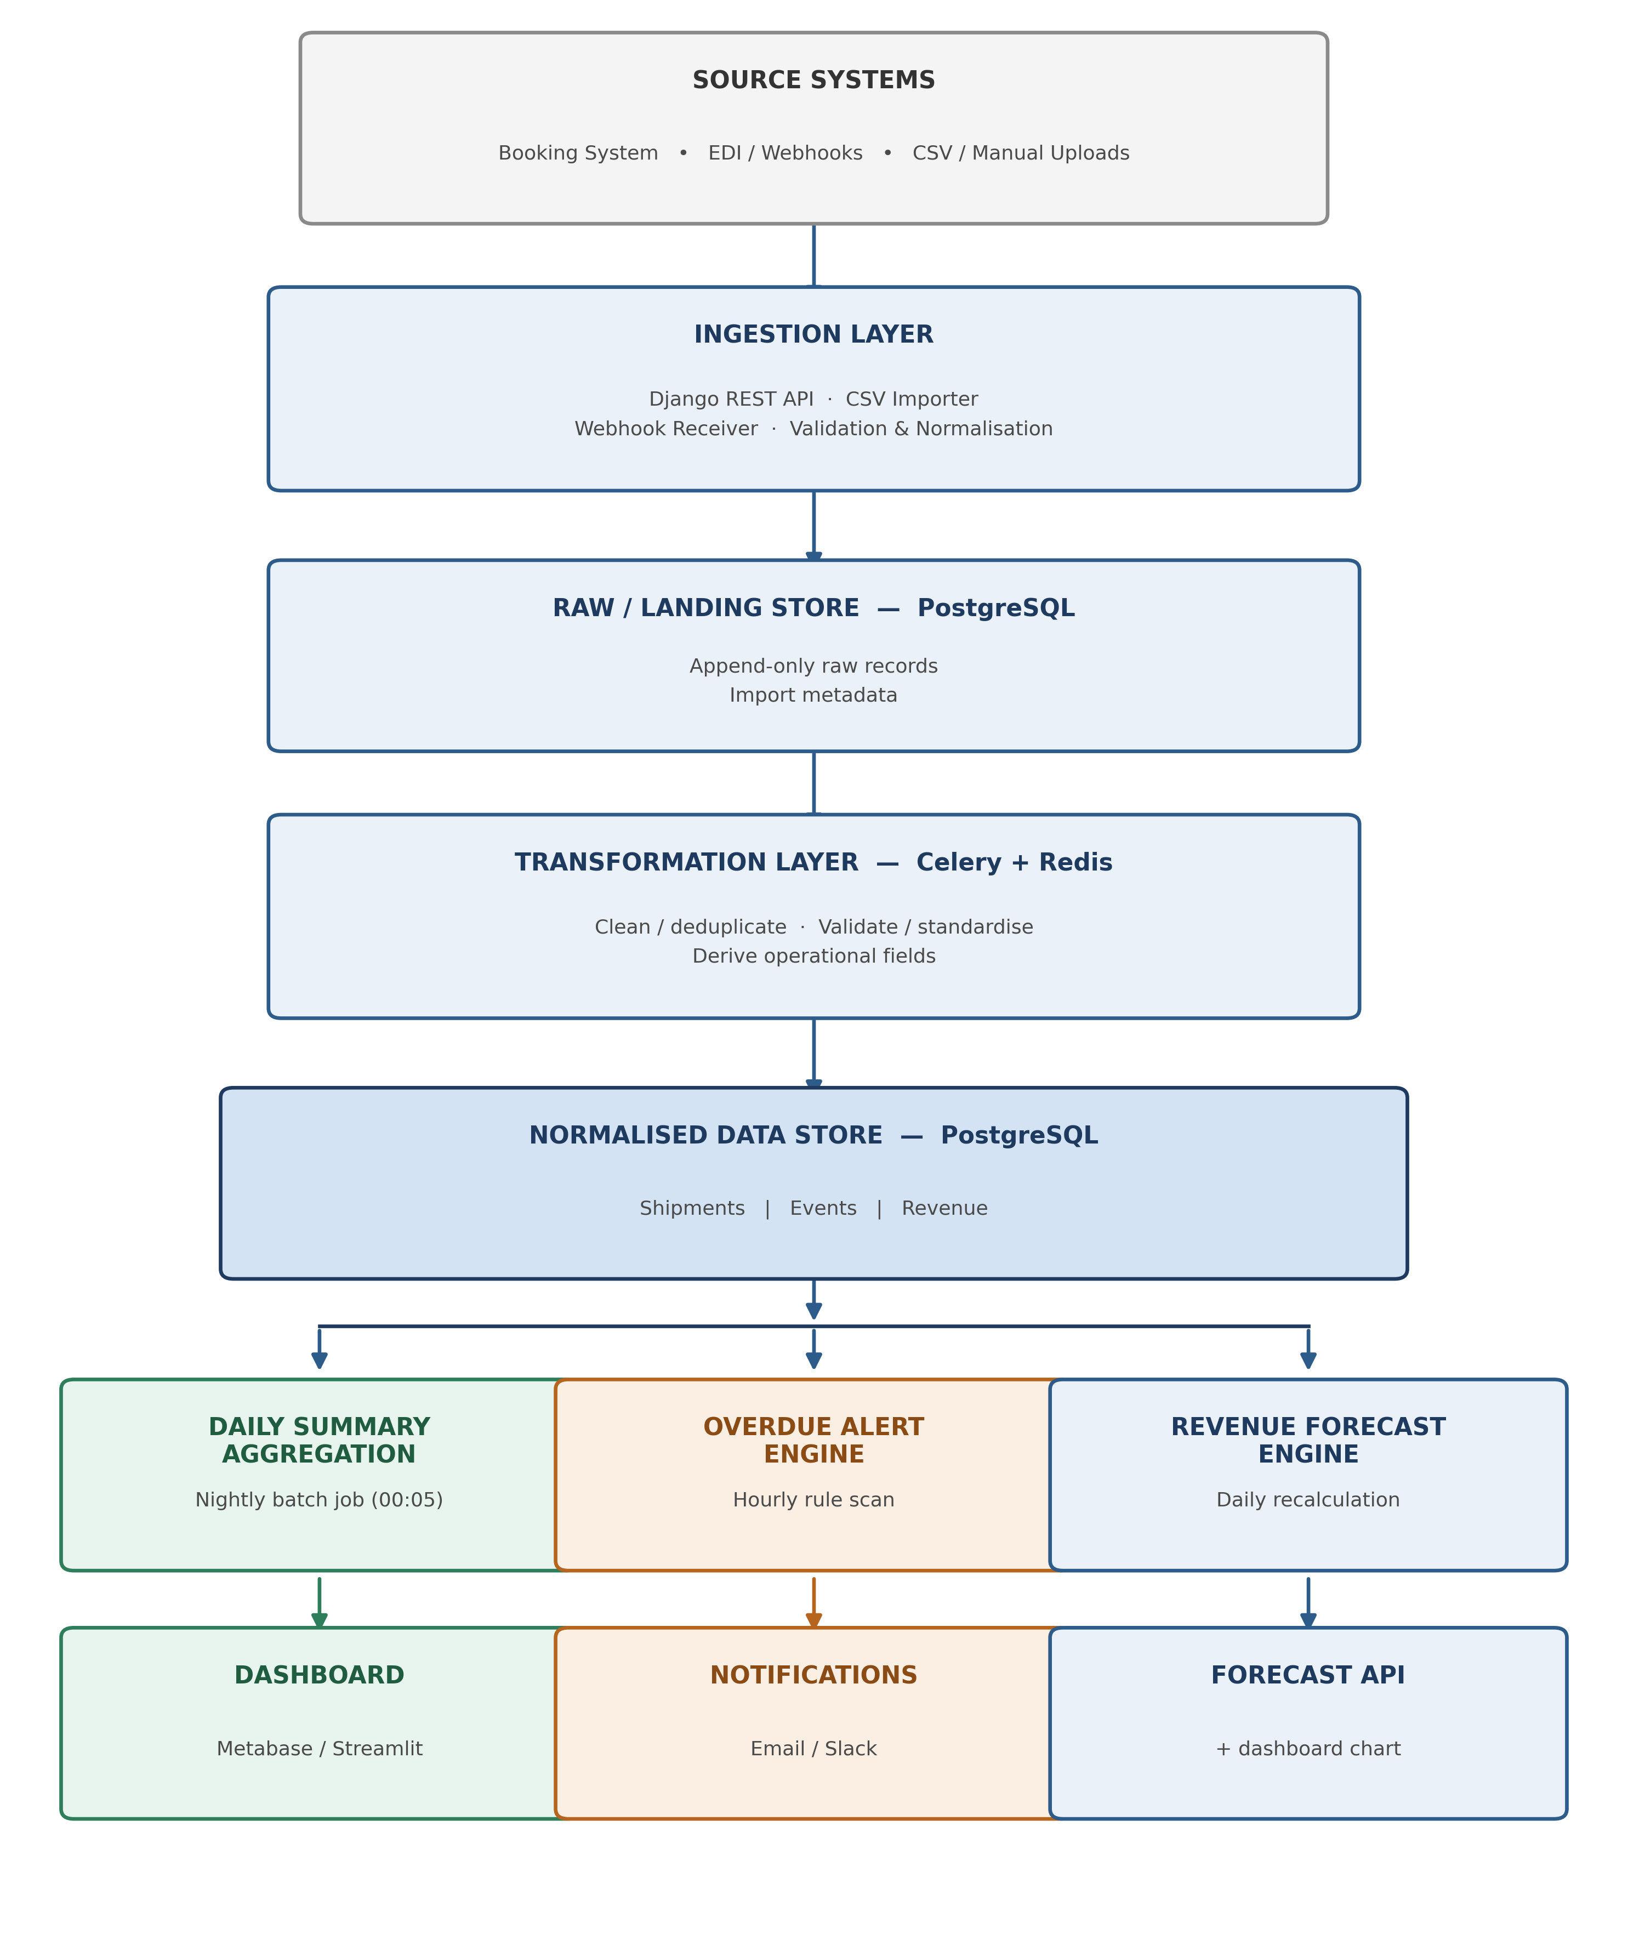
Figure 1: High-level shipment data pipeline architecture

3.1 Architecture Flow
The system follows a layered pipeline:
Ingest → Validate → Store Raw Data → Transform → Store Normalised Data → Analyse → Deliver Outputs
This separation ensures that downstream processes use one consistent source of truth. Raw records are retained for auditability, while cleaned and normalized records are used for analytics.

4. Data Model

4.1 shipments: Core Shipment Entity
Field | Type | Description
shipment_id | UUID / VARCHAR PK | Unique shipment identifier
client_id | FK | Reference to client
origin | VARCHAR | Origin port/city
destination | VARCHAR | Destination port/city
cargo_type | VARCHAR/ENUM | General, hazardous, perishable, vehicle, etc.
weight_kg | DECIMAL | Shipment weight
value_usd | DECIMAL | Declared cargo value
status | ENUM | Current shipment status
eta | TIMESTAMP | Expected delivery/arrival date
vessel_berth_date | TIMESTAMP | Expected vessel berth date where applicable
created_at | TIMESTAMP | Record creation time
updated_at | TIMESTAMP | Last update time
Example statuses:
BOOKED, DOCUMENTS_PENDING, DOCUMENTS_LODGED, IN_TRANSIT, ARRIVED_AT_PORT, CUSTOMS_CLEARANCE, OUT_FOR_DELIVERY, DELIVERED, DELAYED, CANCELLED.

4.2 shipment_events: Shipment History
An append-only event table records every important status transition.
Field | Type | Description
event_id | UUID PK | Event identifier
shipment_id | FK | Related shipment
previous_status | VARCHAR | Previous status
new_status | VARCHAR | New status
event_time | TIMESTAMP | Time of transition
source | VARCHAR | API, CSV, webhook, manual, etc.
Keeping history separately from the current shipment record allows the system to calculate transit times, detect periods without progress, and maintain an audit trail.

4.3 revenue_ledger: Revenue Data
Declared cargo value is not necessarily the same as revenue earned by the logistics company. Therefore, revenue is stored separately.
Field | Type | Description
revenue_id | UUID PK | Revenue record identifier
shipment_id | FK | Related shipment
invoice_date | DATE | Date revenue was invoiced
amount_usd | DECIMAL | Revenue amount
status | VARCHAR | Pending, invoiced, paid, etc.

4.4 Derived Output Tables
The analytics layer produces:
- daily_summary
- alerts
- revenue_forecasts
These are derived datasets and do not overwrite the operational shipment source of truth.

5. Ingestion and Data Validation

5.1 Supported Sources
The system can receive shipment data from:
- Booking/operations applications.
- REST API submissions.
- EDI or webhook feeds.
- Scheduled CSV uploads.
- Controlled manual imports.

5.2 Validation Rules
Incoming records should be validated before entering the normalized dataset.
Examples:
- shipment_id must be present and unique.
- client_name must not be empty.
- origin and destination must be valid non-empty values.
- weight_kg must be numeric and greater than zero.
- value_usd must be numeric and non-negative.
- status must belong to the supported status set.
- Dates must use a consistent timezone/format.
- Required fields must not contain placeholder values such as N/A where a real value is required.
Invalid records should be rejected or quarantined with an error reason rather than silently inserted.

5.3 Deduplication
Ingestion should be idempotent. Re-processing the same batch should not create duplicate shipments.
A practical initial strategy is:
Unique shipment identifier
+
source update timestamp
+
source/import identifier
The raw record is retained, while the normalized shipment is updated only when the incoming record represents a newer valid state.

6. Transformation and Processing Layer
Celery workers execute scheduled and asynchronous processing jobs using Redis as the message broker.
The transformation process performs:
- Schema validation.
- Data type conversion.
- Text/category normalization.
- Status normalization.
- Duplicate detection.
- Date/time normalization.
- Calculation of derived fields.
- Writing of normalized records.
- Recording of processing errors.
A scheduled transformation job can run every 15 minutes for operational data, while daily aggregation and forecasting jobs run on their own schedules.

7. Daily Summary Dashboard

7.1 Purpose
The dashboard provides operations staff and management with a daily view of shipment activity and business performance.

7.2 Metrics
The daily summary should include:

Shipment Operations
- Total active shipments.
- Total shipments created today.
- Shipments by status.
- Shipments by cargo type.
- Shipments by origin and destination.
- Delivered shipments.
- Delayed shipments.
- Shipments currently on customs hold.

Volume and Value
- Total weight handled.
- Total declared cargo value.
- Average shipment weight.
- Average shipment value.

Transit Performance
- Average transit time.
- Average time in current status.
- Number of shipments exceeding ETA.
- Number of shipments approaching ETA.

Revenue
- Revenue invoiced today.
- Revenue invoiced during the current month.
- Revenue by client.
- Revenue by shipment/cargo category where applicable.

7.3 Dashboard Generation
A scheduled Celery job runs shortly after midnight to materialize the previous day's summary into daily_summary.
The dashboard can be implemented using:
- Metabase for the fastest operational deployment.
- Streamlit if a custom/branded analytical interface is required.
The dashboard reads from normalized/derived tables and does not directly modify shipment records.

8. Overdue Shipment Alert System

8.1 Purpose
The alert engine identifies shipments that require operational intervention and sends notifications to the responsible team.

8.2 Alert Rules
A shipment is considered at risk or overdue when one or more rules are triggered.

Rule 1: ETA Exceeded
status = IN_TRANSIT
AND current_time > eta
Severity: HIGH

Rule 2: Customs Hold
status = CUSTOMS_CLEARANCE / CUSTOMS_HOLD
AND no status progress for > 48 hours
Severity: HIGH

Rule 3: Documents Not Lodged
required documents not lodged
AND vessel_berth_date - current_time <= 7 days
Severity: HIGH

Rule 4: Delayed Status
status = DELAYED
Severity: HIGH
Additional rules can be introduced as operational data becomes available.

8.3 Alert Processing
An hourly Celery task:
- Reads current shipments and shipment events.
- Evaluates alert rules.
- Creates an alert when a rule is triggered.
- Avoids creating duplicate open alerts for the same shipment/rule.
- Sends the notification.
- Marks the alert resolved when the underlying condition is cleared.
Example alert:
ALERT: Shipment CLF-2026-002 is overdue.
Status: IN_TRANSIT
ETA: 04 Sep 2026
Current time: 06 Sep 2026
Severity: HIGH
Action: Contact carrier/operations team.

8.4 Notification Channels
Initial implementation:
- Email via SMTP.
- Slack webhook.
Future options:
- Microsoft Teams.
- SMS.
- In-app notifications.

9. 30-Day Revenue Forecasting

9.1 Objective
The forecasting component estimates expected logistics revenue for each of the next 30 days.
The forecast should support planning rather than be treated as a guaranteed financial figure.

9.2 Input Data
The forecasting model uses:
- Historical invoiced revenue.
- Revenue by day.
- Day-of-week patterns.
- Recent revenue trends.
- Known future/booked shipments.
- Expected shipment ETA/berth date.
- Optional client or cargo-level revenue history when sufficient data exists.

9.3 Forecasting Approach
A staged approach is recommended.

Baseline
First aggregate historical revenue into a daily time series and establish a weighted moving-average baseline with day-of-week seasonality.
This provides a simple, explainable model and establishes a benchmark against which more advanced models can be evaluated.

Confirmed Pipeline Adjustment
Known future shipments with expected revenue are incorporated into the forecast.
This is important because a shipment already booked for a future period represents information that a purely historical time-series model cannot see.
Conceptually:
Final Forecast
=
Historical/Statistical Forecast
+
Expected Revenue from Confirmed Pipeline
Care must be taken to avoid double-counting revenue already represented in the historical series.

Upgrade Path
Once sufficient historical data is available, models such as Prophet or statsmodels-based forecasting can be evaluated against the baseline.
Model selection should be based on backtesting performance rather than assuming a more complex model is automatically better.

9.4 Forecast Output
The system produces:
Date | Forecast Revenue | Lower Bound | Upper Bound
Day 1 | Forecast | Interval | Interval
Day 2 | Forecast | Interval | Interval
... | ... | ... | ...
Day 30 | Forecast | Interval | Interval
The forecast is recalculated daily.

9.5 Forecast Evaluation
The forecasting system should be evaluated using historical backtesting.
Recommended metrics:
- MAE: Mean Absolute Error.
- RMSE: Root Mean Squared Error.
- MAPE: Mean Absolute Percentage Error, where appropriate.
A simple baseline should be retained so that management can see whether the forecasting model provides meaningful improvement.

10. Technology Stack
Layer | Technology | Purpose
API/Ingestion | Django REST Framework | Shipment data ingestion
Background processing | Celery | Asynchronous/scheduled jobs
Message broker | Redis | Celery task queue
Database | PostgreSQL | Raw, normalized, event and revenue data
Data processing | Python + pandas | Transformation and aggregation
Forecasting | statsmodels / Prophet | Revenue forecasting
Dashboard | Metabase / Streamlit | Operational reporting
Notifications | SMTP / Slack webhook | Overdue alerts
Testing | pytest / Django tests | Pipeline and rule validation
Deployment | Docker / cloud VM or platform | Reproducible deployment

Heavy technologies such as Kafka or Airflow are intentionally excluded from the initial implementation. They can be introduced later if data volume, workflow complexity, or operational requirements justify them.

11. Scheduling
A simple scheduling model is sufficient for the proposed system.
Job | Frequency | Purpose
Shipment ingestion | Real-time / scheduled | Receive new shipment data
Transformation | Every 15 minutes | Clean and normalize incoming records
Overdue scan | Hourly | Detect operational risks
Daily aggregation | Daily at 00:05 | Generate daily dashboard metrics
Revenue forecast | Daily after aggregation | Produce next 30-day forecast
Alert cleanup | Hourly/daily | Resolve or archive completed alerts

12. Error Handling and Recovery
The pipeline should fail safely.

Ingestion failures
Invalid records are placed into an error/quarantine area with:
- Record identifier.
- Import identifier.
- Error message.
- Timestamp.

Processing failures
Celery tasks should support retries for transient failures.

Database failures
Transactions should prevent partially written normalized records.

Forecast failures
If the forecasting model fails, the system should retain the most recent successful forecast and expose an error status rather than displaying fabricated values.

Alert failures
If notification delivery fails, the alert remains stored in the alert queue so it can be retried.

13. Data Quality and Governance
The following controls are recommended:
- Preserve raw input records.
- Maintain shipment event history.
- Validate required fields.
- Use controlled status values.
- Track record creation and update timestamps.
- Make ingestion idempotent.
- Log transformation failures.
- Separate operational data from derived analytics.
- Restrict dashboard access according to user roles.
- Protect client and commercial information.
- Back up PostgreSQL data regularly.
This is particularly important because shipment, client, and financial data should be traceable and reproducible.

14. Security Considerations
The system should include:
- Authenticated ingestion endpoints.
- Role-based dashboard access.
- HTTPS for API communication.
- Environment variables for credentials and secrets.
- Database access controls.
- Validation of uploaded CSV files.
- Rate limiting on externally exposed endpoints where appropriate.
- Audit logging for important data changes.
Sensitive client and financial information should not be exposed through public dashboards or logs.

15. Scalability and Future Improvements
The initial design is intended for a small-to-medium logistics operation and can scale incrementally.

Phase 1
- PostgreSQL.
- Django REST Framework.
- Celery + Redis.
- Metabase/Streamlit.
- Basic forecasting.
- Email/Slack alerts.

Phase 2
- Automated EDI integrations.
- More detailed operational KPIs.
- Improved forecast models.
- Role-specific dashboards.
- Automated data-quality monitoring.

Phase 3
If data volume and event throughput become substantially larger:
- Kafka for high-volume event streaming.
- Airflow or another workflow orchestrator for complex data pipelines.
- Dedicated analytical warehouse/lakehouse.
- More advanced forecasting and anomaly detection.
The architecture therefore avoids premature complexity while leaving clear upgrade paths.

16. End-to-End Example
Consider a shipment with:
Shipment ID: CLF-2026-002
Client: Example Importer
Origin: Shanghai
Destination: Durban
Cargo: General Goods
Weight: 8,500 kg
Value: USD 45,000
Status: IN_TRANSIT
ETA: 04 September 2026

Step 1: Ingestion
The shipment is received through the REST API or CSV importer.

Step 2: Validation
The pipeline verifies the required fields, numeric values, status and dates.

Step 3: Storage
The raw record is retained and the valid shipment is written to the normalized shipments table.

Step 4: Event Processing
Status changes are recorded in shipment_events.

Step 5 Overdue Detection
If the current date is later than the ETA while the shipment remains IN_TRANSIT, the overdue rule triggers.

Step 6: Alert
A HIGH severity alert is created and sent to the operations team.

Step 7: Dashboard
The shipment contributes to the daily counts, weight/value totals, and overdue shipment KPI.

Step 8: Forecast
If the shipment is associated with known future revenue, its expected revenue can contribute to the confirmed pipeline component of the 30-day revenue forecast.

17. Key Design Decisions

17.1 One normalized source of truth
The dashboard, alert engine and forecasting process should consume the normalized data layer rather than independently processing raw files.

17.2 Raw data is preserved
Raw input is retained so that processing errors can be investigated and historical records can be reproduced.

17.3 Derived data is separated
Daily summaries, alerts and forecasts are derived outputs and should not overwrite operational shipment records.

17.4 Rules before complexity
Overdue detection is implemented using transparent business rules rather than an ML model. This makes alerts explainable and easy for operations staff to validate.

17.5 Forecasting starts with a baseline
A simple statistical baseline is established before introducing more complex forecasting models. This makes model improvement measurable.

18. Conclusion
The proposed pipeline provides a practical end-to-end solution for turning shipment data into operational intelligence.
The architecture:
Ingests → validates → stores → transforms → analyses → delivers
It directly satisfies the three requirements of Task 2:
- Daily summary dashboard for operational visibility.
- Overdue shipment alerts for proactive intervention.
- 30-day revenue forecasting for planning and decision-making.
The design favors reliability, auditability, explainability and maintainability over unnecessary infrastructure complexity.

